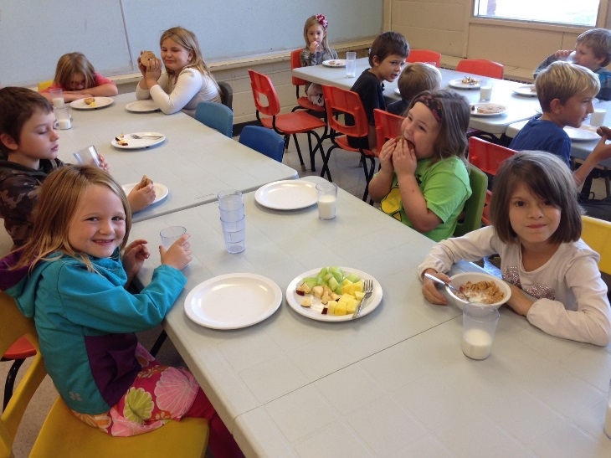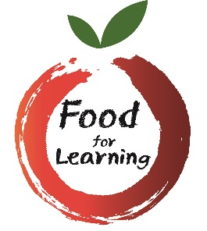

SCHOOL LOGO HERE

**School Name Here**

**Prepare & serve breakfast and early morning meals**

Contact Vicky Struthers at (613) 966-1170 ext. 2378

vstruthers@hpedsb.on.ca

Vicky Struthers

(613) 966-1170 ext. 2378

vstruthers@hpedsb.on.ca

Vicky Struthers

(613) 966-1170 ext. 2378

vstruthers@hpedsb.on.ca

Vicky Struthers

(613) 966-1170 ext. 2378

vstruthers@hpedsb.on.ca

Vicky Struthers

(613) 966-1170 ext. 2378

vstruthers@hpedsb.on.ca

Vicky Struthers

(613) 966-1170 ext. 2378

vstruthers@hpedsb.on.ca

Vicky Struthers

(613) 966-1170 ext. 2378

vstruthers@hpedsb.on.ca

Vicky Struthers

(613) 966-1170 ext. 2378

vstruthers@hpedsb.on.ca

Vicky Struthers

(613) 966-1170 ext. 2378

vstruthers@hpedsb.on.ca

Vicky Struthers

(613) 966-1170 ext. 2378

vstruthers@hpedsb.on.ca

Vicky Struthers

(613) 966-1170 ext. 2378

vstruthers@hpedsb.on.ca

**Contribute to a healthy start for healthy minds**

**Local Student Nutrition Program requires support**

Volunteers Needed